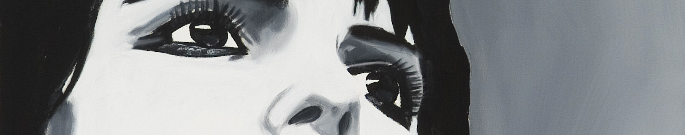
Matthew Kyme CV

Matthew John Kyme
Born: March 1980, New Zealand
Currently lives and works in Melbourne

EDUCATION

2003 Graduate Diploma in Education.
The University of Melbourne
Double method of Visual Art

2001 Bachelor of Art (Painting)
RMIT University

1998 Diploma of Visual Art (Painting)
Northern Metropolitan Institute of TAFE

EXHIBITION HISTORY

2006: ‘Them and Us’, 4Cats Gallery, Abbotsford

‘Strangers Occupying Space’, McCulloch Gallery, Melbourne

‘Flotsam and Jetsam’, Reaktion Art Space, Abbotsford

‘Four Sides of the Fence’, McCulloch Gallery, Melbourne

‘Strangers and Heroes’, Brunswick Arts Gallery, Brunswick

'New Artists at Span', SPAN Gallery, Melbourne

McCulloch Gallery, Melbourne

Golden Gargoyle Art Supplies, 288 Albert Street, Brunswick

2005: Golden Gargoyle Art Supplies, 288 Albert Street, Brunswick

'2005 Summer Exhibition', SPAN Gallery, Melbourne

'Homage to Modern Masters', Port Art Gallery, Port Melbourne

'Summer Show', Wall Gallery, Ascot Vale

Port Art Gallery, Port Melbourne

2003: ‘Shop Stop Art' Melbourne Fringe Festival, Melbourne

‘Artz Blitz’ Kingston Arts Centre, Moorabbin

‘Student Exhibition’ University of Melbourne, Melbourne

2002: Williamstown Art Prize Exhibition, Williamstown

2001: ‘Deep’ Graduate Exhibition, RMIT University, Melbourne

'Senini Art Award' Exhibition, McClelland Gallery, Langwarrin

2000: ‘Recent works’ Paintings, Metropolitan Café, Melbourne

‘New Directions’, Curated by Shaun Wilson, Indigo Gallery, Camberwell,

1999: ‘Paintings’, Gallery 33, Richmond

‘Dots and Loops’ Paintings, Truffle Pig Restaurant, Sandringham

‘Recent works’ Paintings, Truffle Pig Restaurant, Sandringham

1998: ‘Chaos in the Court’, Paintings and Prints, Eltham Courthouse, Eltham

