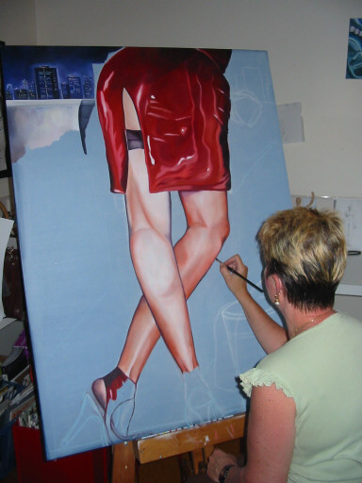

EDUCATION

2005 Batchelor of Fine Art – present
2nd Year, Major Painting

EMPLOYMENT

1992-2005 Practicing Artist – present

2000-2005 Community Education Tutor

2000-2005 Artist in Residence Brigidine College, Brisbane

ARTWORKS ON SALE AT:

RM Galleries, Hamilton, Qld.

The Rainbird Gallery, Montville Q.

Moving Canvas, NEW FARM Q.

Framez & Dezign, BUNDALL, GOLD COAST.
EXHIBITIONS:

2006

RM Galleries, Grand Opening Selected Group Showing 3 March.

2005

GPO Hotel, 740 Ann St, Fortitude Valley Q. (selected group showing)

Sopranos Restaurant, Broadbeach, Q

2004

The Stones Corner Café, Stones Corner, Brisbane Q.

Sugar Bar, Mary Street, Brisbane Q.

The Point Hotel, Kangaroo Point, Brisbane Q.

COMMISSIONS:

Private Commissions in Brisbane, Gold Coast, Los Angeles, U.S.A. & Japan, New Zealand

MEDIA COVERAGE:

South West News, Vibe Arts Supplement ,2004
The Great South East, Channel 7 lifestyle coverage, Brisbane, 1999
Our House Supplement, Courier Mail, Brisbane, 1999
The Brisbane News, Design Works Supplement Brisbane, 1999
The Satellite, Sherwood/Centenary Ed. 2000

COMPETITIONS:

She Who Inspires, Walker St Gallery, Victoria 2005
Nudgee Arts Competition, 2004
John Paul College Arts Festival 1996/1997
Caloundra Arts Festival, 1996
ARTIST STATEMENT:

Being an undergraduate at present in 2nd year of my formal training as a Fine Arts Student, majoring in painting, I am being asked the question by my painting lecturer “what do I want to get out of painting and if I had a choice, what would I want to paint? These can sometimes be difficult to answer on the spot but on reflection I answered that the most important thing I feel I wanted is for people to appreciate my work.

With that in mind, the way I express myself is in my figurative style of work. The female form is the most appropriate way to do this with an emphasis on today’s society with powerful women, wealth, status symbols and relationships. I am never short of ideas for my next painting by the overload of images that circulate within our society all driven to sell a particular product. These images use young, attractive women to sell everything from perfume, cars, jewellery and even holidays.

Painting is part of my everyday life. Narrative figurative painters such as V.R. Morrison, Anwen Keeling, and Anne Wallace influence me. I find the works of Helmut Newton inspiring. He took his camera out of the studio and filmed what he saw. Nothing was staged. His photographs are a great source for my work. I use models where I can but rely on black and white photography for staging compositions of my works.

I am also drawn to the renaissance era and to 15th and 16th century painters like Caravaggio and Titian for their use of shadows into light. The Surrealist painter Rene Magritte also is inspiring for his dramatic style and hint of mystery.

My work is greatly influenced by colour and design. Fashion and jewellery are a part of my compositions. Their beauty and their appeal influence my work. I like to use the female form as part of my compositions and “dress it up” with these trappings to present independent and successful women in today’s society.

I have often been asked who the females in my paintings are. The viewer then goes on to say that they thought they recognized them. I tell them no, it’s not someone that might have recognized or know. I like to keep the identities of the models unknown for the present, and let the paintings tell the story, if there is indeed one to tell.

For my mind, they are just pleasing to look at and I like to leave it at that. No more, no less.

RHONDA FERLING
ANSTEAD, QLD 4070

